1. Ask questions about the requirements.

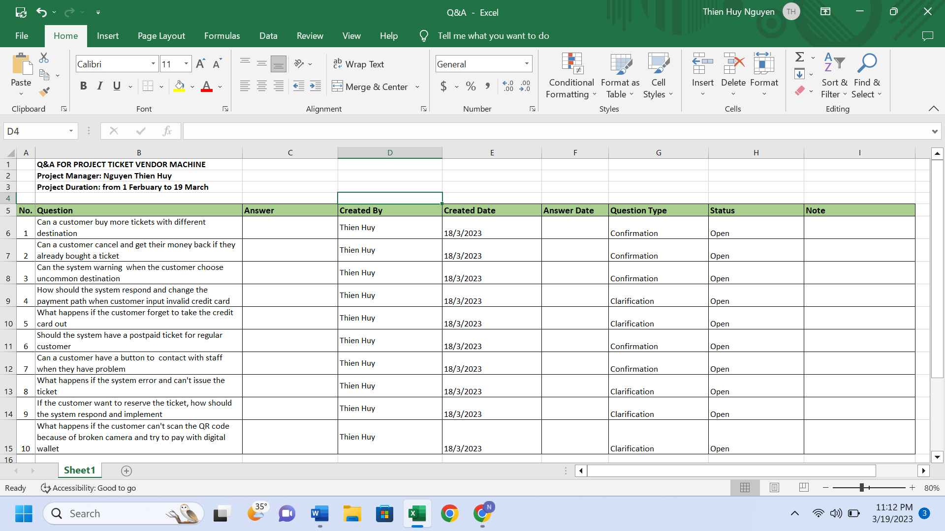

1. Write a set of functional, non-functional and domain requirements for a Ticket Vendor Machine.

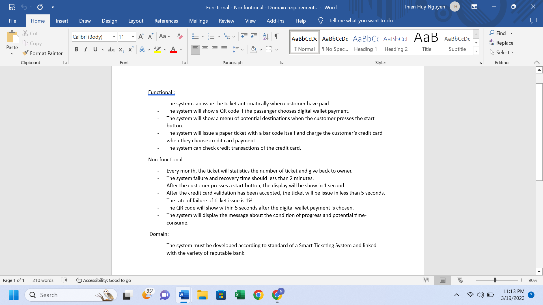

1. Develop Use Case Modelling

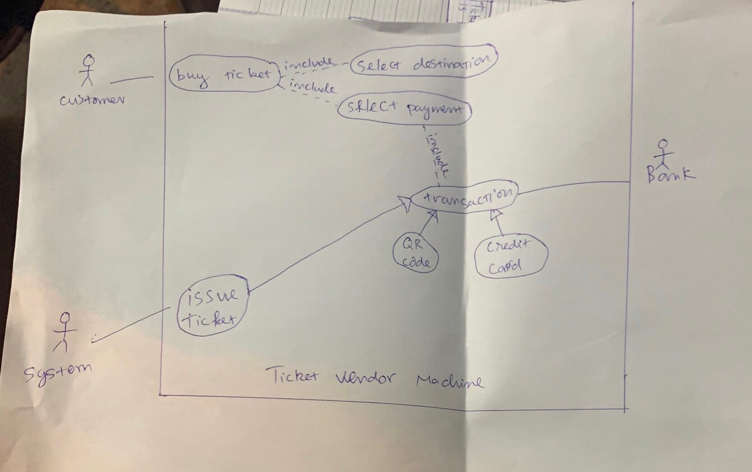

Description:

1. The user press Start.
2. The menu of destination displayed.
3. The user choose destination.
4. The menu of payment displayed.
5. The user choose payment way.
6. If pay with Credit Card is chosen, the user is requested to input Credit Card.
7. If pay with Credit Card is chosen, the ticket is issued when the credit transaction has been validated.
8. If pay with QR code is chosen, the QR code will be showed.
9. The user scan and provide information.
10. The ticket is issued when the data transaction has been validated.
11. Make an activity diagram

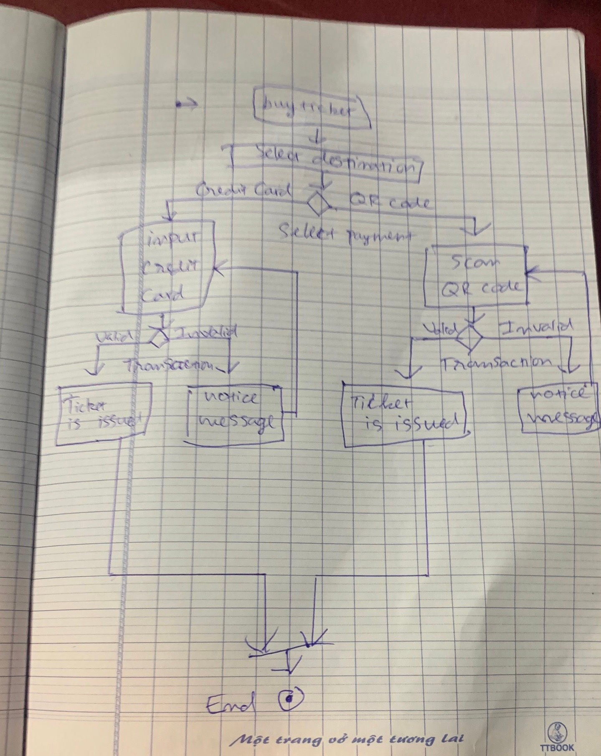

Activity diagram to present the process of passenger’s buying a ticket

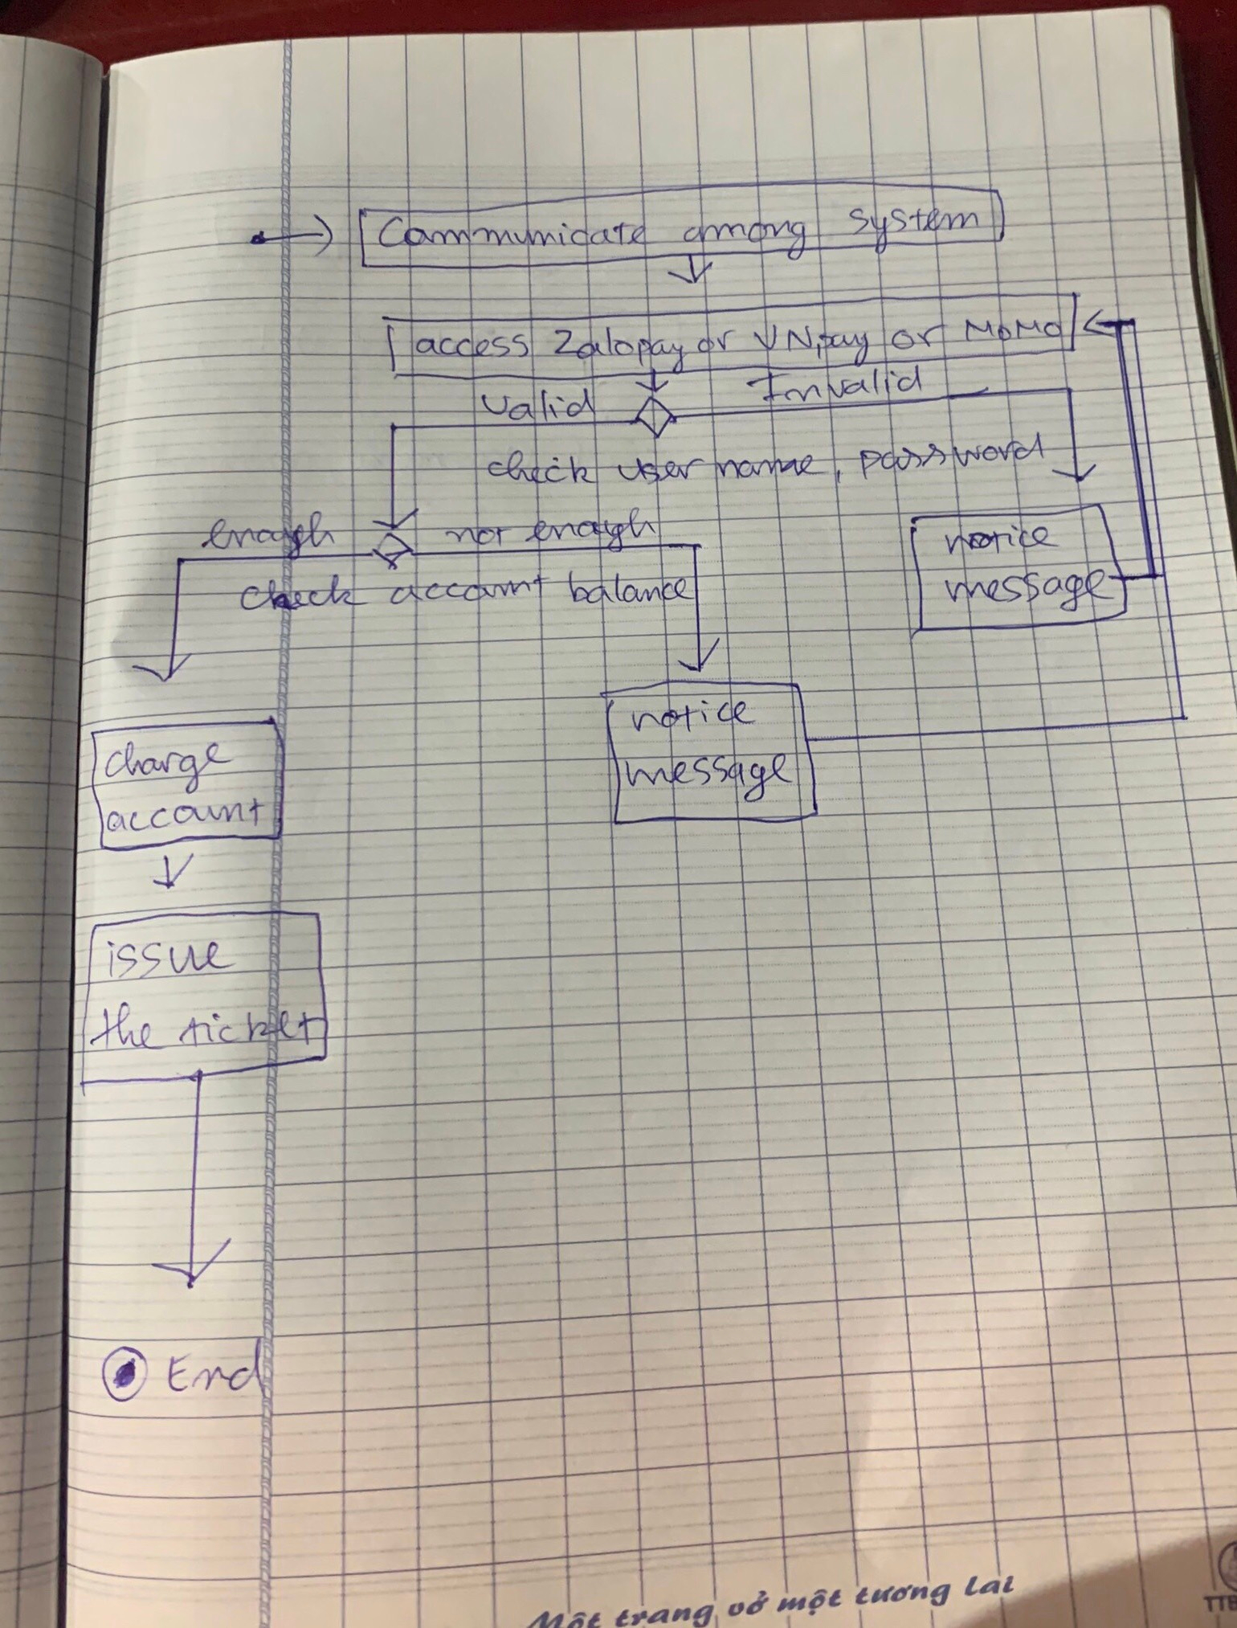 Activity diagram for communication among systems

1. complete the sequence diagram, State chart diagram, and Class diagram

